MARK L. MARISCOTES
A. Title: Final Project
The primary objective of this project is to identify the U.S. state that shows the best potential for business expansion, considering factors such as state income and corruption rates.

B. Title: Project Overview & Analysis Steps
Our project focuses on exploring potential relationships between socioeconomic factors, like income levels, and crime rates, which are represented by corruption convictions per capita across different U.S. states. We gathered data from various states detailing their income distribution and crime rates.
The methodology for this project includes:
- Data Cleaning,
- Exploratory Data Analysis or EDA,
- Hypothesis Testing,
- Correlation Analysis, and finally,
- Drawing insights and conclusions based on our analysis.

C. Title: Preliminary Findings
In our preliminary analysis, we noticed that states with higher average incomes tend to have slightly lower convictions per capita, suggesting a minor negative correlation between income and corruption. However, this relationship is not very strong, and we should be cautious in attributing statistical significance to this observation.
Highest Income States
State | Avg. Income | % Convictions
Maryland | 89,392 | 1.63%
Massachusetts | 82,427 | 2.68%
New Jersey | 81,740 | 2.24%
California | 80,440 | 1.29%
Connecticut | 79,287 | 2.37%

Lowest Income States
State | Avg. Income | % Convictions
West Virginia | 46,254 | 6.66%
Mississippi | 47,131 | 2.87%
New Mexico | 48,701 | 2.53%
Arkansas | 48,829 | 3.56%
Kentucky | 50,675 | 1.89%

D. Title: Correlation Analysis
In the correlation analysis, we found an approximately -0.14 correlation between total state income and corruption convictions per capita. This weak negative relationship indicates that as the total state income increases, the corruption convictions per capita tend to decrease slightly. However, it's important to understand that correlation is not causation, and these are only preliminary findings.

E. Title: Geographic Income Distribution
Looking at our geographical data, the map depicts each state with darker colors representing higher income and lighter colors indicating lower income. Generally, states with higher incomes are located along the coastlines.
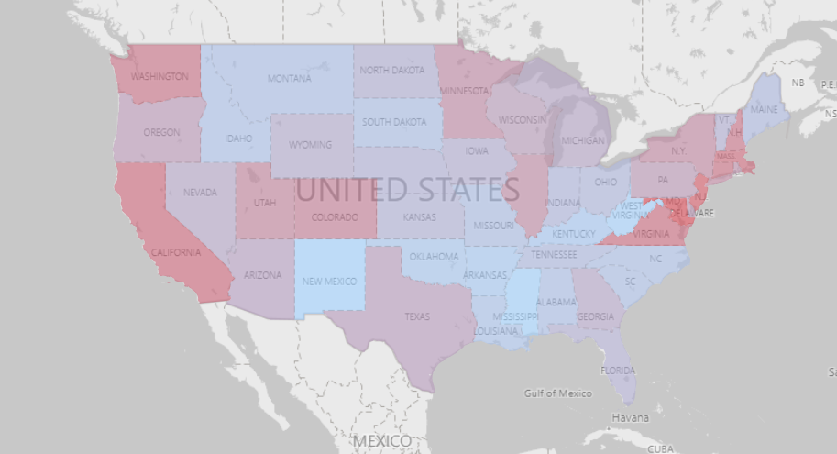

F. Title: Histogram of Total Income Distribution
This histogram shows the distribution of total income across all states. It indicates a right-skewed distribution, meaning a majority of states have lower total incomes, while only a few states have significantly higher incomes.
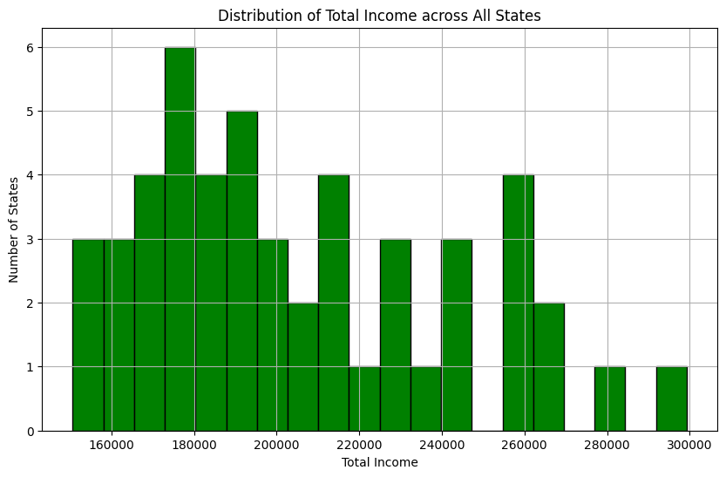
G. Findings
From these results, we can say that there is a slight tendency for states with higher incomes to have lower conviction rates, but the relationship is not strong. It is therefore important to consider other factors such as tax rates, labor costs, and market demand, should also be considered.

H. Insights
The analysis suggests that Maryland, with the highest average income, may have fewer convictions per capita compared to other states. This could be attributed to the possibility that states with higher average incomes tend to allocate more resources to law enforcement, education, and social services, or that the culture in these states is less tolerant of criminal behavior. Conversely, West Virginia, with the lowest average income, may have higher convictions per capita due to potential resource constraints or different social dynamics

I. Answers to Business Questions
In the process of selecting optimal locations for business expansion, I highly recommend considering states such as California, New Hampshire, and Hawaii. These states have demonstrated a potent combination of high average incomes and low conviction rates, making them prime candidates for business expansion.
High average incomes in these states suggest a strong local economy and a potential customer base with significant purchasing power. This could translate into a higher demand for your products or services, contributing to increased sales and profits. Furthermore, a thriving economic environment often indicates a supportive infrastructure for businesses, including well-established transportation, logistics, and communications systems.

J. Recommendations
- States with high average incomes like Maryland, indicating a strong economy and potential customer base with significant purchasing power.
- States with low conviction rates like Hawaii, potentially indicating lower levels of corruption and a more reliable business environment.
- States with low income disparity like New Mexico, suggesting a more balanced consumer base and stable socio-economic conditions.
- States with both high incomes and low conviction rates, such as California, New Hampshire, and Hawaii, which might be favorable candidates for business expansion.
However, it is emphasized that these recommendations are general and must be complemented with detailed market research, feasibility studies, and an understanding of local laws and regulations to make an informed decision specific to the particular business scenario.

K. Challenges Encountered During the Analysis
The analysis faced challenges with determining causal relationships due to the correlation versus causation issue. Additionally, the dataset had limited variables, omitting important factors like education, unemployment rates, and demographic data. The accuracy and completeness of the provided data played a crucial role in the analysis, as any inaccuracies or missing information could have affected the results. Moreover, the insights derived were general and might not be applicable to all businesses or specific scenarios, as business expansion decisions require a more comprehensive understanding of the market and business environment.
Regenerate response

L. Recommendations for Future Research
To improve the analysis, include a more comprehensive set of variables that could influence income levels and conviction rates, such as education levels, unemployment rates, population demographics, cost of living, tax rates, and local laws and regulations.
To gain a deeper understanding of the trends over time, consider obtaining data from multiple years for a longitudinal analysis, which can help investigate whether changes in one variable lead to changes in another.

